Position Title: | AmeriCorps Member | Service  Category: | CORE Susquehanna  AmeriCorps
Service Site: | TIU 11 | Date  Submitted: | 5/6/2020
Site Address: | 2527 US Hwy 522 South McVeytown, Pa. | Travel  Required: | to sites
Compensation: | Living Stipend - $ 14,279.00  Education Award - $ 6,195.00 | Service Term: | August 25, 2020 to August 7th,  2021
Host Site Supervisor: | Brett Gilliland | Email: | bgilliland@tiu11.org
Phone: | 814 542 2501 | Posting URL: | www.coreamericorps.org
Applications Accepted By: |  | Person and phone to contact for interview if different from supervisor:
Email Dennis Huratiak, CORE Susquehanna AmeriCorps
Program Director dhuratiak@union-snydercaa.org
Member Position Summary
The Mission of CORE Susquehanna is to serve community needs through member service in areas of Healthy Futures, Education, Volunteer Management and Community Service Projects.
In addition to the member position summary and duties, ALL AmeriCorps members are required to participate in
CORE AmeriCorps Group Activities. AmeriCorps members may not participate in any activities included in the Prohibited Activities as listed in the ‘Partner Site and Member Agreements’.
- will work in small group or individual with students under supervision of teacher
- will work to improve students academic skills
- will increase attendance
- will assist on social emotional needs of students
- will work to collaborate with agencies for secondary transition when appropriate

Duties and/or required training
- high school diploma
- clearances as required by education settings

Prohibited Activities
In order to comply with federal regulations, AmeriCorps members assigned to this site are prohibited from:

- Attempting to influence legislation;
- Organizing or engaging in protests, petitions, boycotts, or strikes;
- Assisting, promoting, or deterring union organizing;
- Impairing existing contracts for services or collective bargaining agreements;
- Engaging in partisan political activities, or other activities designed to influence the outcome of an election to any public office;
- Participating in, or endorsing, events or activities that are likely to include advocacy for or against political parties, political platforms, political candidates, proposed legislation, or elected officials;
- Engaging in religious instruction, conducting worship services, providing instruction as part of a program that includes mandatory religious instruction or worship, constructing or operating facilities devoted to

religious instruction or worship, maintaining facilities primarily or inherently devoted to religious instruction or worship, or engaging in any form of religious proselytizing.
- Providing a direct benefit to a business organized for profit, a labor union, a partisan political organization; a nonprofit organization that fails to comply with the restrictions contained in section 501(c)(3) of the Internal Revenue Code of 1986 except that nothing in this section shall be construed to prevent participants from engaging in advocacy activities undertaken at their own initiative, and an organization engaged in the religious activities, unless Corporation assistance is not used to support those religious activities.
- Conducting a voter registration drive or using Corporation funds to conduct a voter registration drive;
- Providing abortion services or referrals for receipt of such services; and
- Such other activities as the Corporation may prohibit.

Further Guidance on Prohibited Activities of Providing Abortion Services and Referrals

Providing abortions services is limited to:
- Performing abortions.
- Being present in the room during an abortion in support of the woman or the procedure.
- Obtaining or providing medications to induce a medical abortion.

Referrals for abortion services is limited to:
- Scheduling or arranging for an abortion-related appointment, including any pre-procedure appointment required by law to obtain an abortion.
- Providing or organizing transportation for patients to obtain an abortion when the AmeriCorps member or assigning staff member has actual prior knowledge that the purpose of the visit is to obtain an abortion.
- Accompanying or providing translation services for patients obtaining an abortion.
- Providing counseling or support before or during the procedure, including explaining what the procedure will be like, explaining what’s required to obtain an abortion in a given state, explaining or obtaining signed abortion consent forms from clients interested in abortions, negotiating fees or insurance coverage for a particular abortion, or other activity that promotes or encourages abortion.
- Providing information such as the name, address, website, telephone number, or other relevant factual information (such as whether the provider accepts Medicaid, etc.) about an abortion provider.
- Promoting or encouraging use of abortion as a method of family planning.

Minimum Qualifications (Academic, Physical or Experience)
●
Proposed Weekly Schedule and Required Number of Hours per week.
School hours approximately 40 hours a week

Will the member be serving vulnerable populations (children, youth, elderly, disabled)?
☒​ Yes ☐​​ No
Will the contact with vulnerable populations be episodic or reoccurring?
☐​ Episodic ☒​​ Reoccurring
I understand the expectations and requirements of this position. I understand that this position description is an addendum to the AmeriCorps Member Agreement.
Member Name:
Signature of Member Accepting Position: |  |  | Date:
Signature of Site Supervisor: |  | 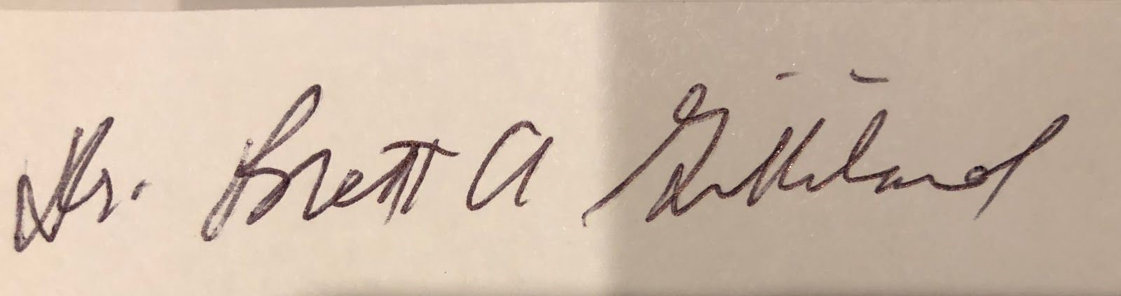 | Date:5/7/2020

